Comp 421 Homework 3

* Initially I read the data from images and labels csv files.
* Then I assigned the label data y_truth and split this data from the half,

assigning the first half the training set and the second half the test set for both samples.

- I specified number of hidden layers

* I derived :
  + Number of observations
  + Number of features
  + Number of classes

- The key in this homework was creating the one hot encoded label data set. I created it just afterwards.

* I defined two functions. Two functions for weights gradient. One of them is for going into hidden layer from input layer (w) and the other one is for going from hidden layers to output layers. These two functions are going to be used when I am applying gradient descent to find the optimal weights during back and foreward propagation methods in the multilayer perceptron algorithm.
  + I defined sigmoid, safelog and softmax functions in the following phase
  + I specified learning parameters
  + I created errors array and in the while loop I applied gradient descent method to find the minimal error. This errors array will be used for plotting the errors in every iteration. When the loop reaches max iteration or error difference becomes smaller than the epsilon value, loop terminates and the plot for error, confusion matrices for test and training data sets in accordance with my predicted-y results.

Below is the output of my results:

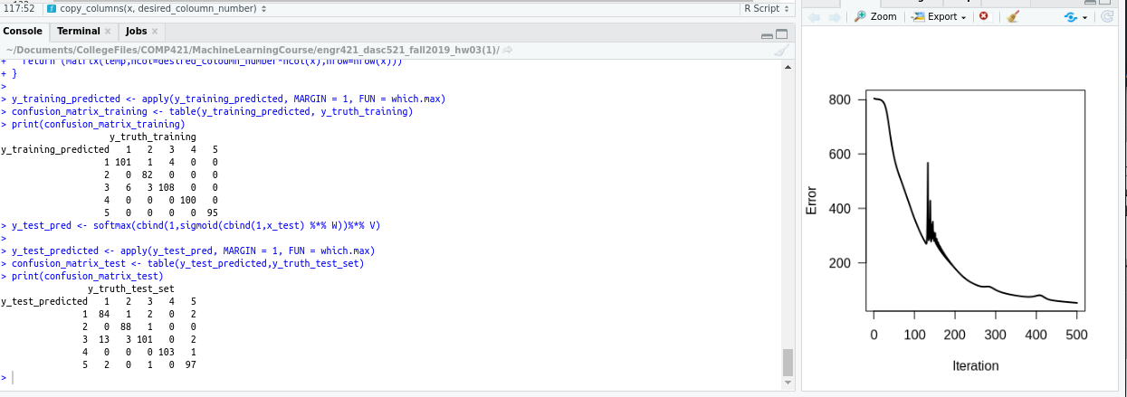

Emre Uludağ